**Project Title:**

Global Migration Insights: Refugee Movements and Happiness Trends

**Project Summary**

This Power BI report provides a comprehensive analysis of global migration patterns and their correlation with happiness metrics. It explores data on refugee movements, trust in government, and GDP per capita to derive actionable insights on migration and well-being.

**Purpose**

To analyze the interplay between refugee movements, happiness indices, and socio-economic factors such as GDP and trust in government, providing insights for policymakers, humanitarian organizations, and researchers.

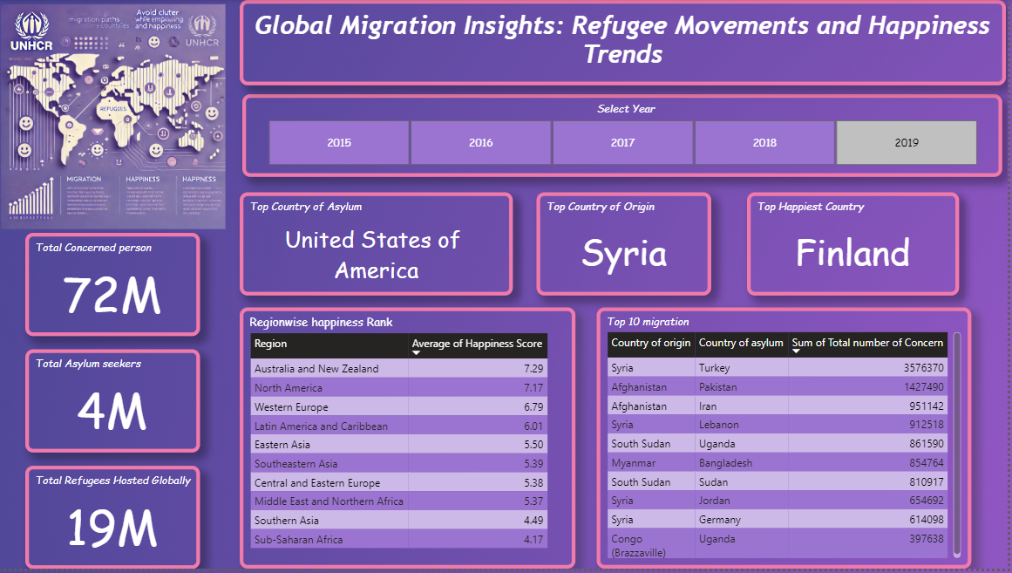

**Page 1 Insight:**

**Syria as the Leading Country of Origin**:

* Across all analyzed years, Syria consistently remains the top country of origin for refugees.

**Developed Countries as Major Hosts**:

* The top countries of asylum are predominantly developed nations, such as the **United States** and **Germany**, showcasing their significant role in accommodating refugees.

**Finland: The Happiest Country**:

* Finland consistently ranks as the happiest country, demonstrating strong socio-economic stability and support systems.

**Regional Happiness Trends**:

* Regions like **Australia and New Zealand** and **North America** consistently hold the highest happiness ranks.
* Conversely, regions like **Southern Asia** and **Sub-Saharan Africa** rank at the bottom, highlighting disparities in well-being.

**Largest Migration Flows**:

* The most significant migration flow occurs from **Syria to Turkey**, followed by **Afghanistan to Pakistan** between 2015 and 2019.

**Countries with the Most People of Concern**:

* **Turkey** and **Pakistan** host the highest numbers of people of concern, reflecting their pivotal roles in addressing global migration challenges.

**Page 2 Insight:**

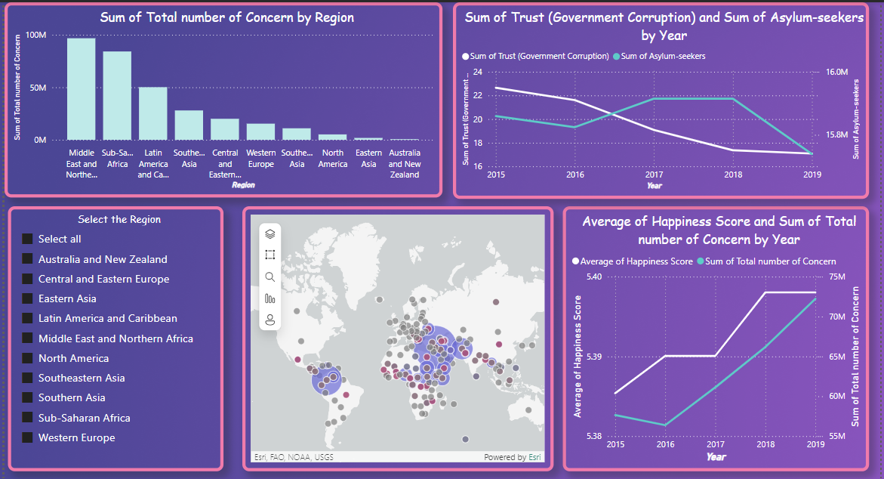

**Middle East and North Africa Lead in Total Concerned Persons**:

* When analyzing total numbers of people of concern across all regions, the **Middle East and North Africa** ranks at the top, followed by **Sub-Saharan Africa** in second place.
* The bar graph illustrates a clear hierarchy, with a downward trend in the remaining regions.

**Decline in Trust in Government and Asylum Seekers**:

* A line chart reveals a noticeable decline in **overall trust in government** over the years, accompanied by a downward trend in the average number of asylum seekers globally.

**Increase in Happiness Scores and Total Concerns**:

* Another line chart indicates that:
  + The **average happiness score** across all regions shows an upward trend over the years.
  + The **total number of concerned persons** is also steadily increasing.
* The decline in asylum seekers coupled with the rise in total concerns suggests an increase in other categories, such as **internally displaced persons (IDPs)** and **stateless persons**.

**No Apparent Correlation Between Happiness and Total Concerns**:

* Regionally, the data suggests no clear correlation between the **happiness of people** and the **total number of people of concern**, as both metrics are increasing over time.

**Page 3 Insight:**

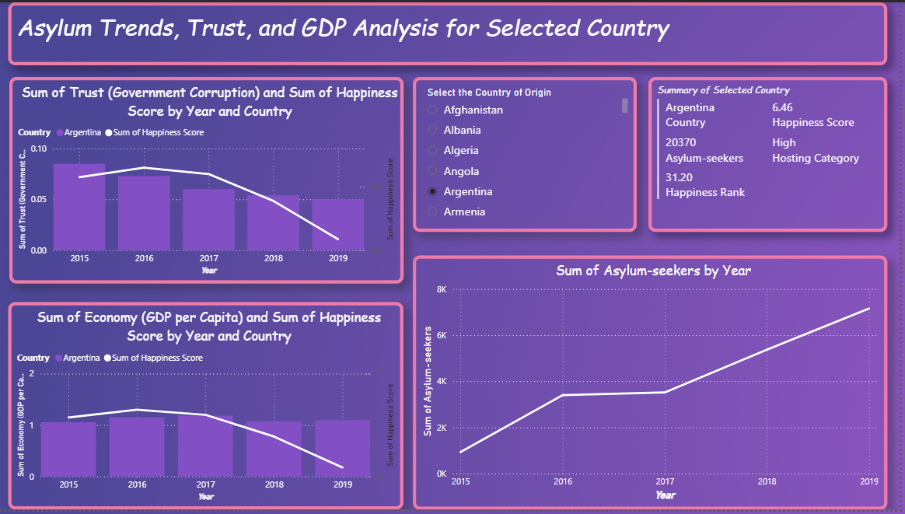

• **Dynamic Country Selection for In-Depth Analysis**:

* This page allows users to select a **Country of Origin** from the slicer to analyze:
  + The **Asylum Seeker Trend** for the selected country.
  + The correlation between **Trust in Government** and **Happiness Score**.
  + The relationship between **GDP per Capita** and **Happiness Score**.

**Country-Specific Trends Vary Significantly**:

* Trends and correlations differ across countries, highlighting unique socio-economic and migration dynamics for each.

**Example Insights**:

* **Syria (Highest Number of Concerns)**:
  + **Asylum Seekers**: Increasing over the years.
  + **Trust in Government**: Slightly decreasing.
  + **GDP per Capita**: Remains relatively constant.
  + **Happiness Score**: Increased initially and then stagnated over time.
* **Finland (Happiest Country)**:
  + **Asylum Seekers**: Decreasing over the years.
  + **GDP per Capita**: Remains stable.
  + **Trust in Government**: Consistent.
  + **Happiness Score**: Continues to increase steadily.
* **Afghanistan**:
  + **Asylum Seekers**: Increasing consistently.
  + **Trust in Government**: Declining over time.
  + **GDP per Capita**: Slightly fluctuating.
  + **Happiness Score**: Decreasing steadily.

**Dynamic Exploration for Any Country**:

* This report empowers users to select any country and dynamically explore its unique trends, enabling a deeper understanding of the impact and correlations between asylum seeker trends, trust in government, GDP per capita, and happiness scores.

**Conclusion:**

This Power BI project provides a comprehensive analysis of global migration trends and their interplay with socio-economic factors such as happiness scores, trust in government, and GDP per capita. By integrating refugee data with the World Happiness Index, this report uncovers valuable insights into the dynamics of asylum seeker flows, the socio-political impact of migration, and the resilience of nations in the face of humanitarian challenges.

Key takeaways from the analysis highlight:

* **Syria as a dominant origin country** for refugees, with neighboring countries like Turkey and Pakistan bearing the brunt of hosting responsibilities.
* Developed nations like the USA and Germany also play a pivotal role as top asylum destinations.
* **Happiness scores and migration trends** often exhibit unique, region-specific dynamics, with no clear global correlation observed.
* Dynamic trends in **trust in government**, GDP, and happiness across countries like Syria, Finland, and Afghanistan showcase the complexity of the migration experience and its impact on host and origin countries.

The interactive features of this report, including country and year-level slicers, empower users to explore these dynamics in depth, providing a flexible and insightful tool for policy analysts, humanitarian organizations, and researchers.

This project demonstrates how data-driven storytelling can shed light on global issues and facilitate informed decision-making. While the report successfully presents meaningful trends and insights, there is room for enhancement, such as enabling map visuals for geographical insights and expanding the scope to include additional socio-economic factors.

In conclusion, this Power BI report serves as a strong foundation for understanding global migration and its socio-economic implications, bridging the gap between data analysis and impactful storytelling. It invites stakeholders to delve deeper into the underlying patterns and correlations, fostering actionable strategies for addressing global migration challenges.